# AI ASSISTED CODING

# ASSIGNMENT-4.5

NAME:S.VRINDHA REDDY

HALL NUMBER:2403A51255

BATCH:11

Prompt:

Create 10 short email samples. Each email should belong to one of these categories: Billing, Technical Support, Feedback, Others.

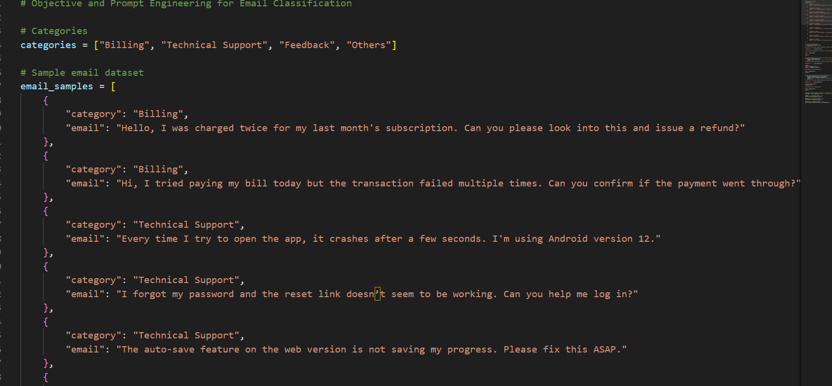

Zero-short Prompt:

Classify the following email into one of the following categories: Billing, Technical Support, Feedback, Others.

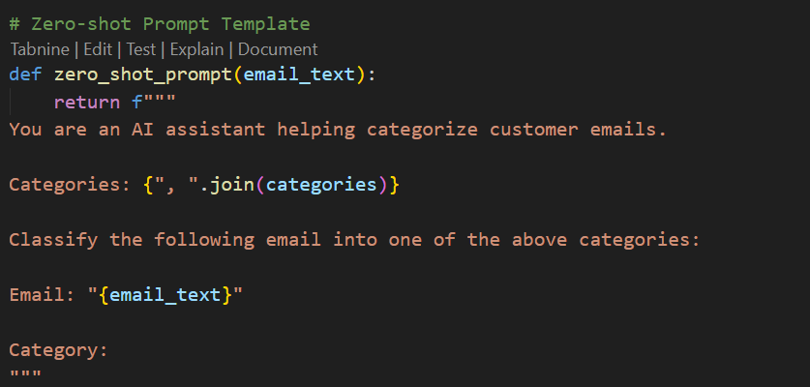

One-short Prompt:

Classify the following email into one of the following categories: Billing, Technical Support, Feedback, Others.

Few-short Prompt:

Classify the following email into one of the following categories: Billing, Technical Support, Feedback, Others.

Output:



